TRADER (PHP) Guide

1. First, you need to go to the **homepage** of Nature’s Fresh Mart and then you can find **LOGIN** button at the navigation bar.

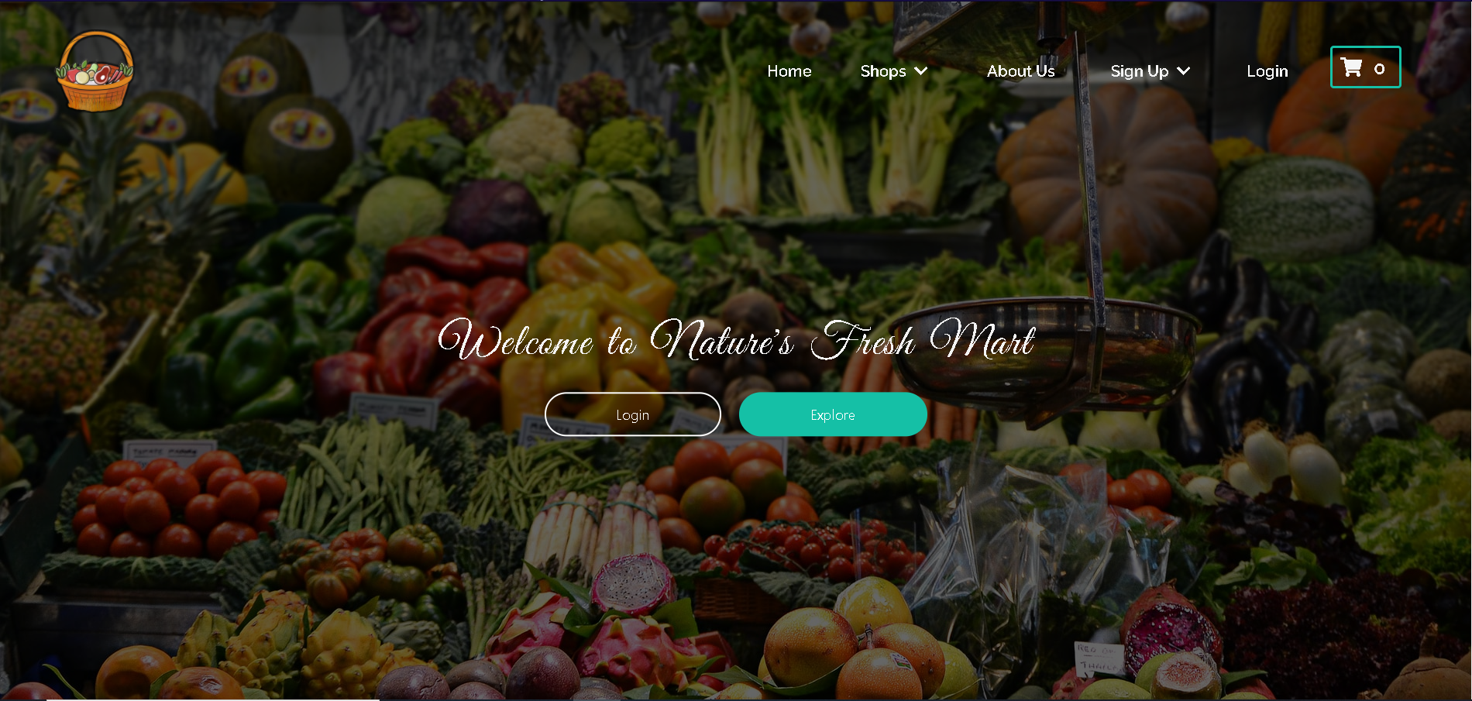

1. Then in the **Login page**, choose trader as your user type and login using your credentials

[neplese931@gmail.com](mailto:neplese931@gmail.com)

password: Saugat123

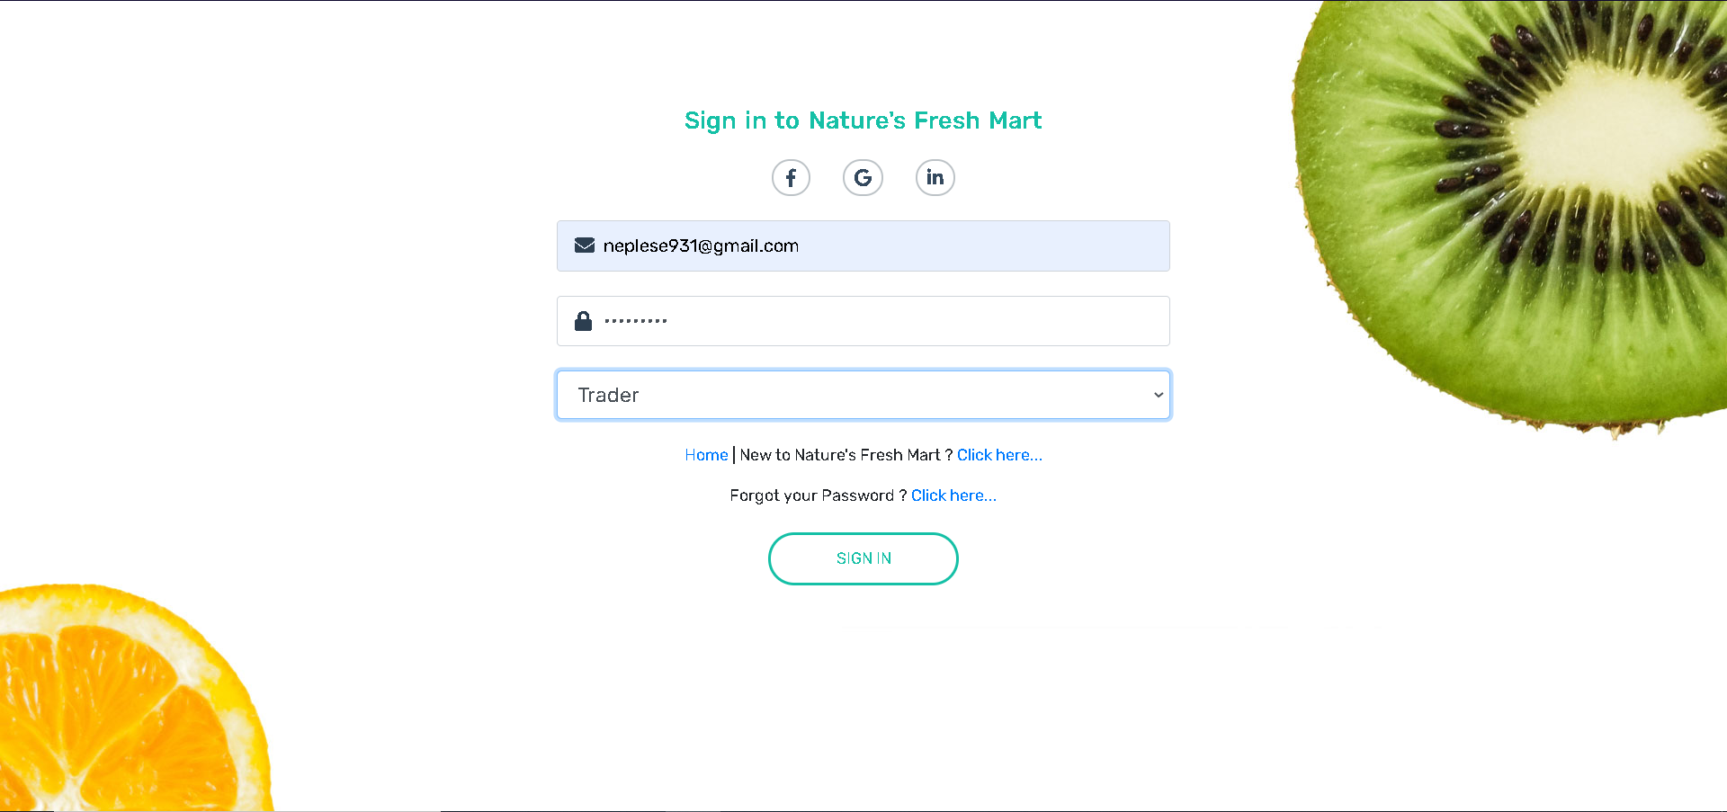

1. Once the correct trader login credentials are filled you will be redirected to the **homepage** from where you can access your **Trader Panel** by clicking the user icon in the navbar as displayed below

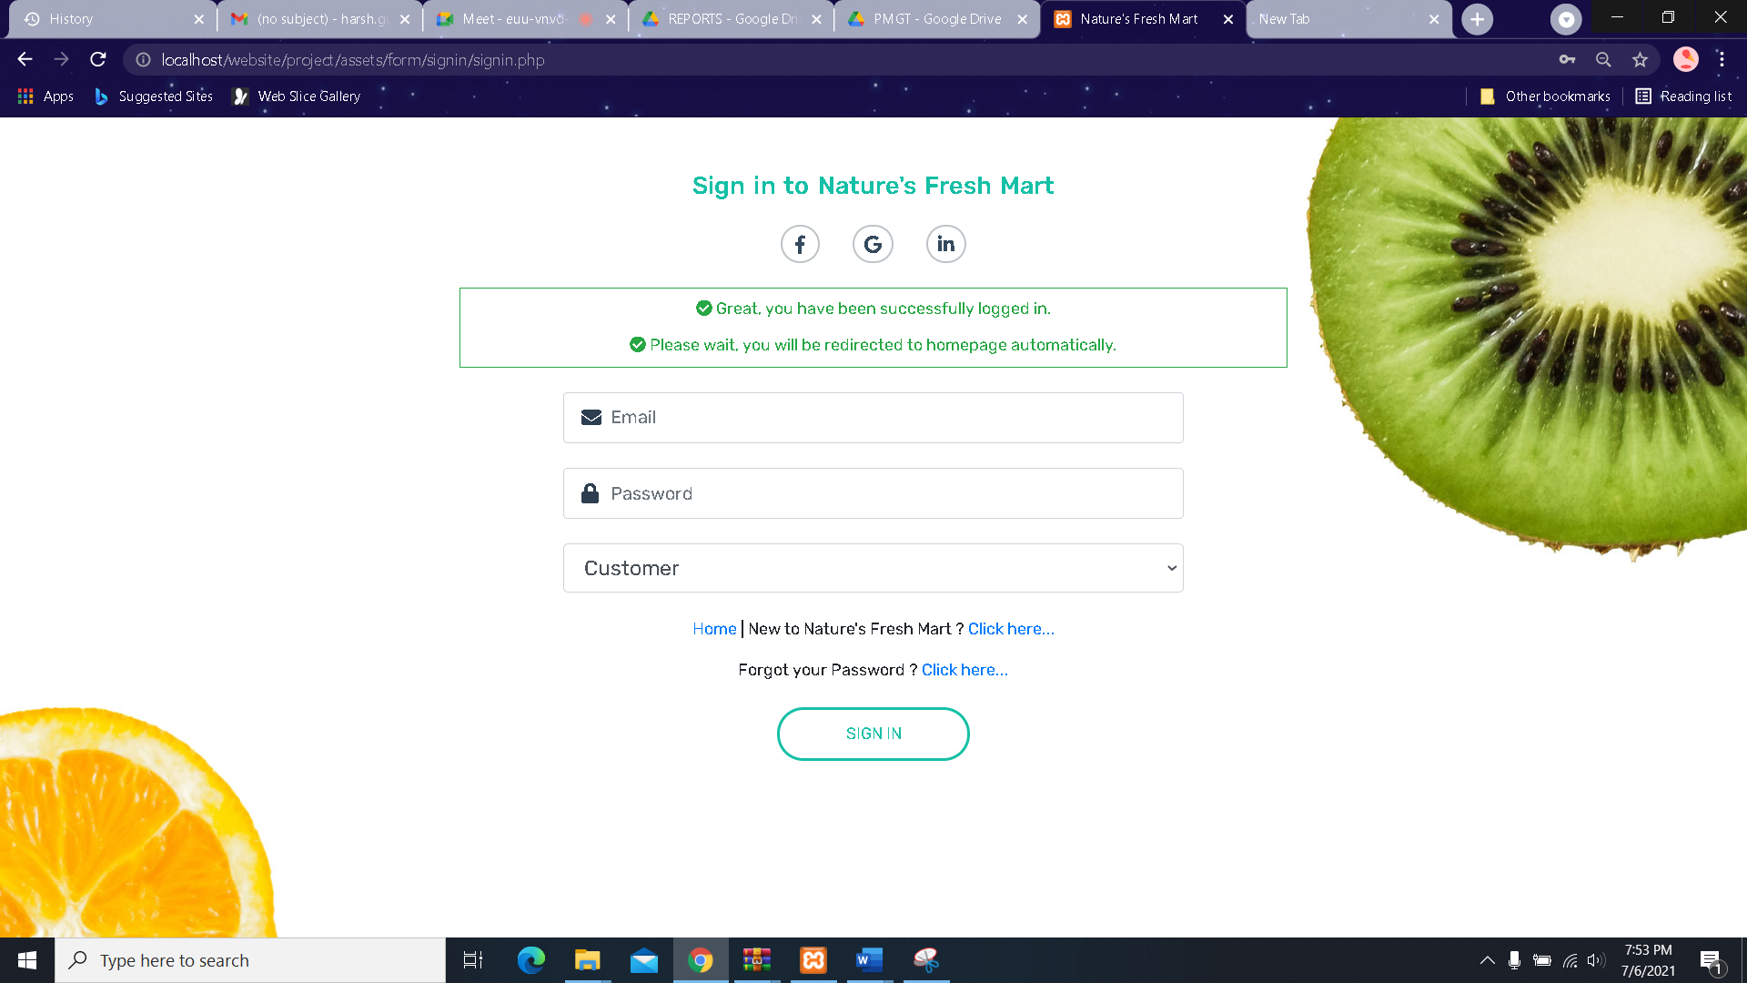

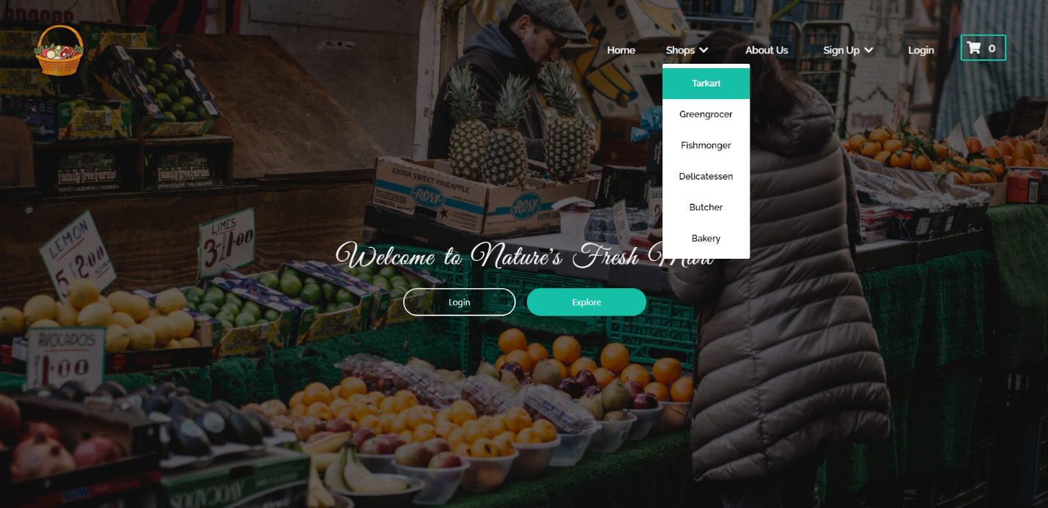

* **If you want to register as new trader, you can fill up signup form**

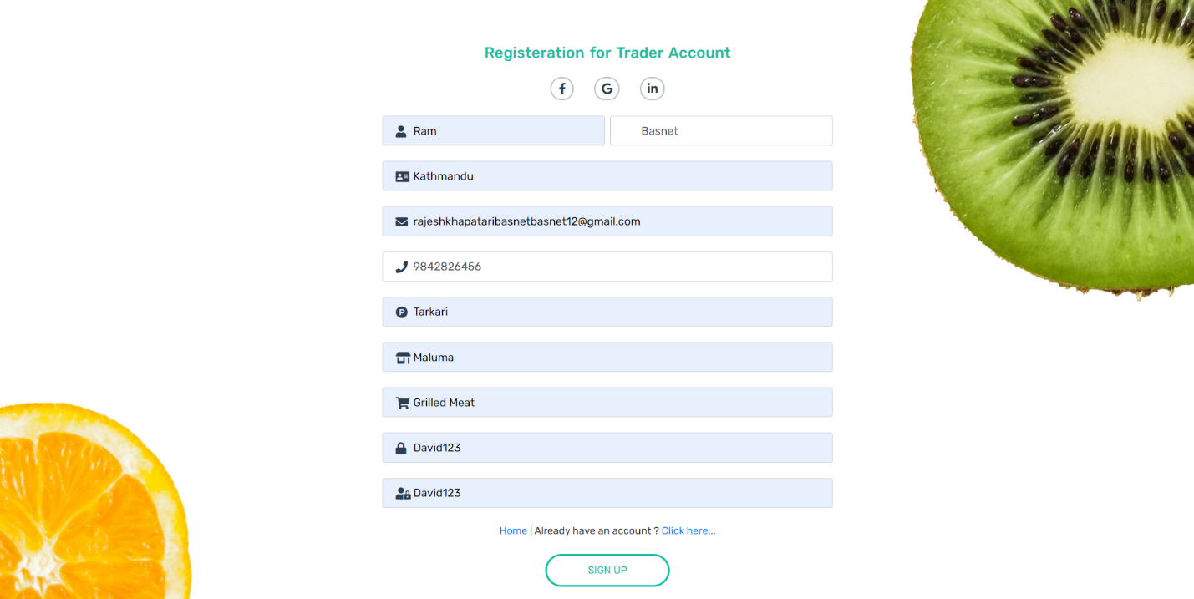

* Email verification sent to admin

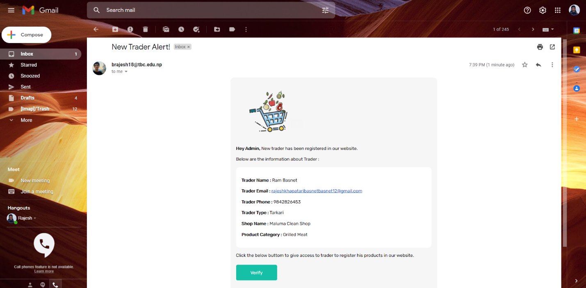

* After Trader is verified, he receives email of confirmation.

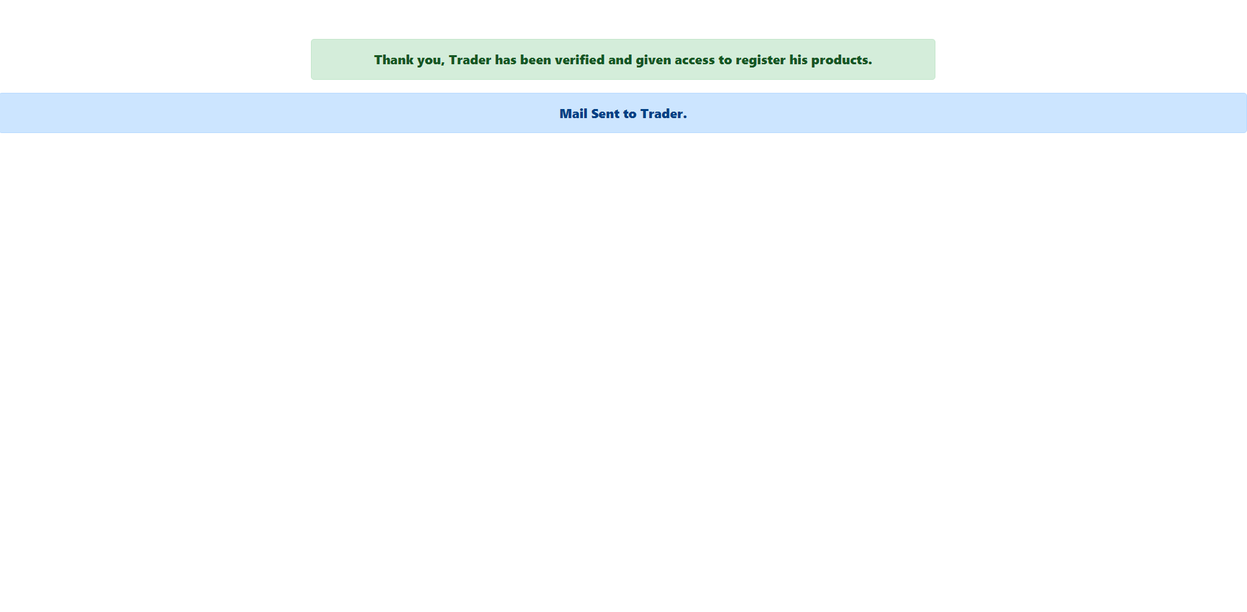

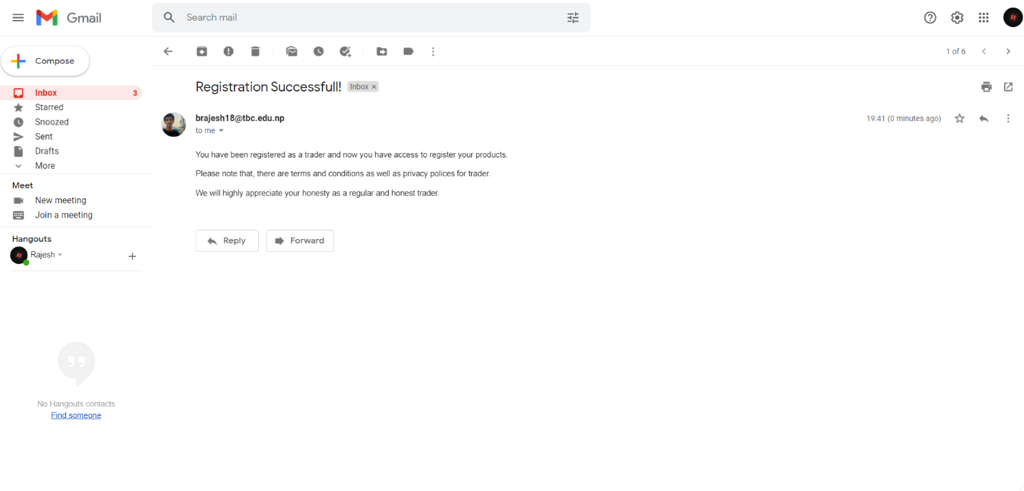

After Verification, we can see the trader listed in website



After this Trader can login with valid credentials from email sent by Admin

1. Once inside the **Trader Panel** the first option you’ll see is the Dashboard where you’ll see the all the orders made to your shop by the customers

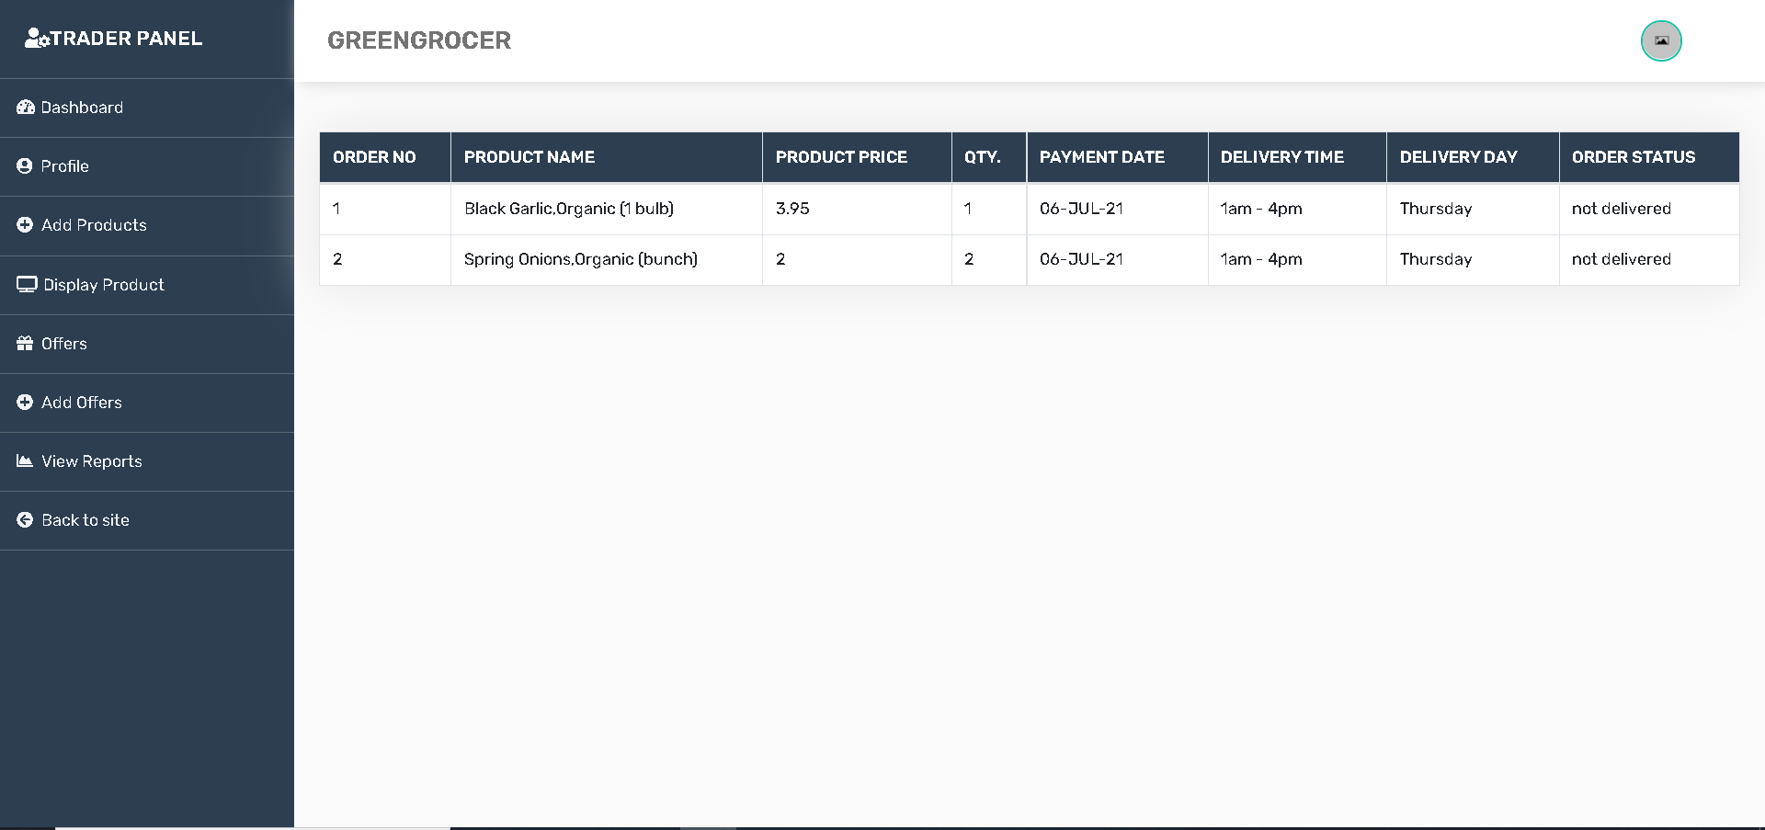

1. The second option you’ll see is the **Profile** section where you can update your personal information like your name, email, phone number and so on

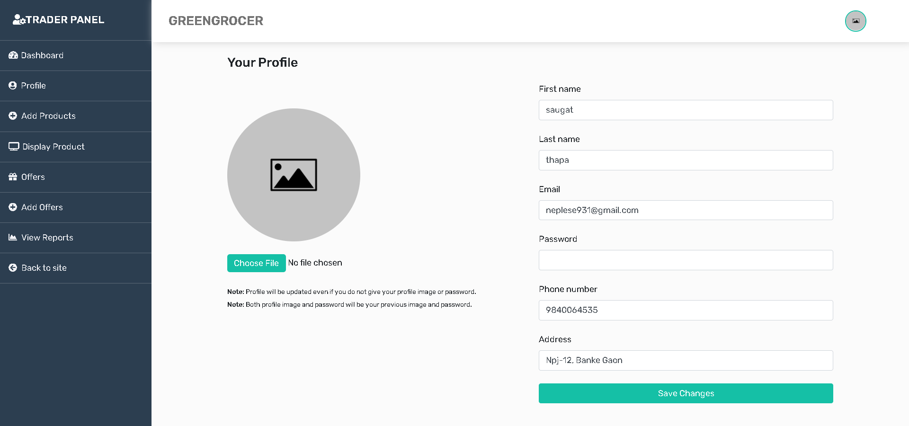

1. The third option you’ll find is the **Add Product** section where you can add new items by filling out the forms as shown below

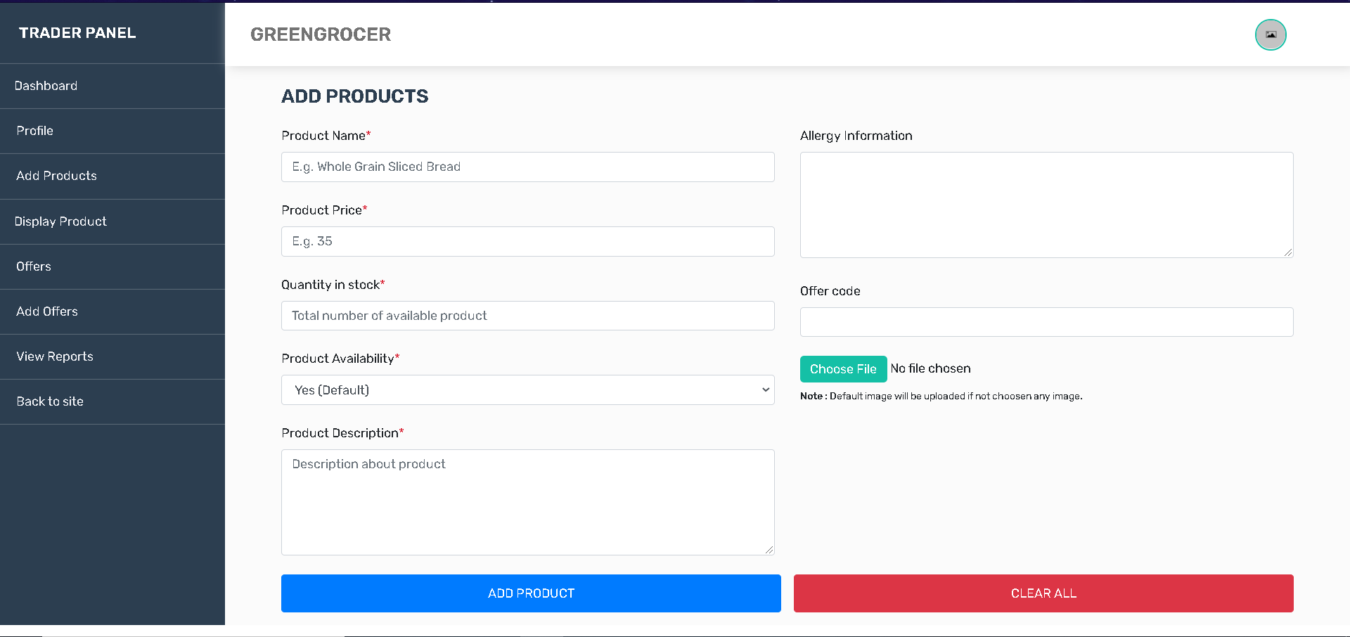

1. The next section is the **Display Product** section where you can see all the products you’ve added till now and every information relating to those products.

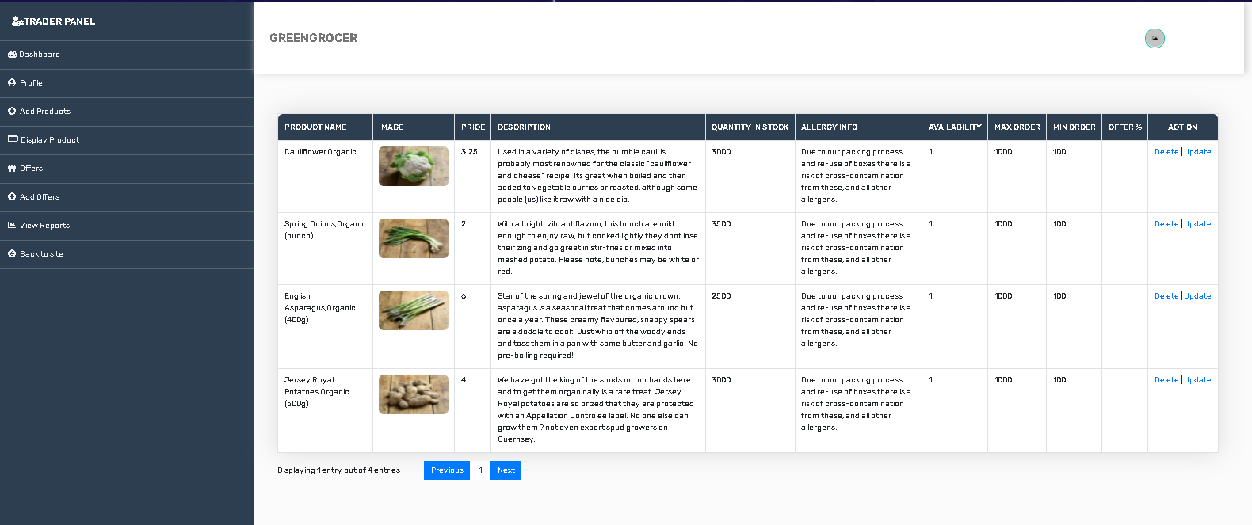

**Delete** Product button is pressed

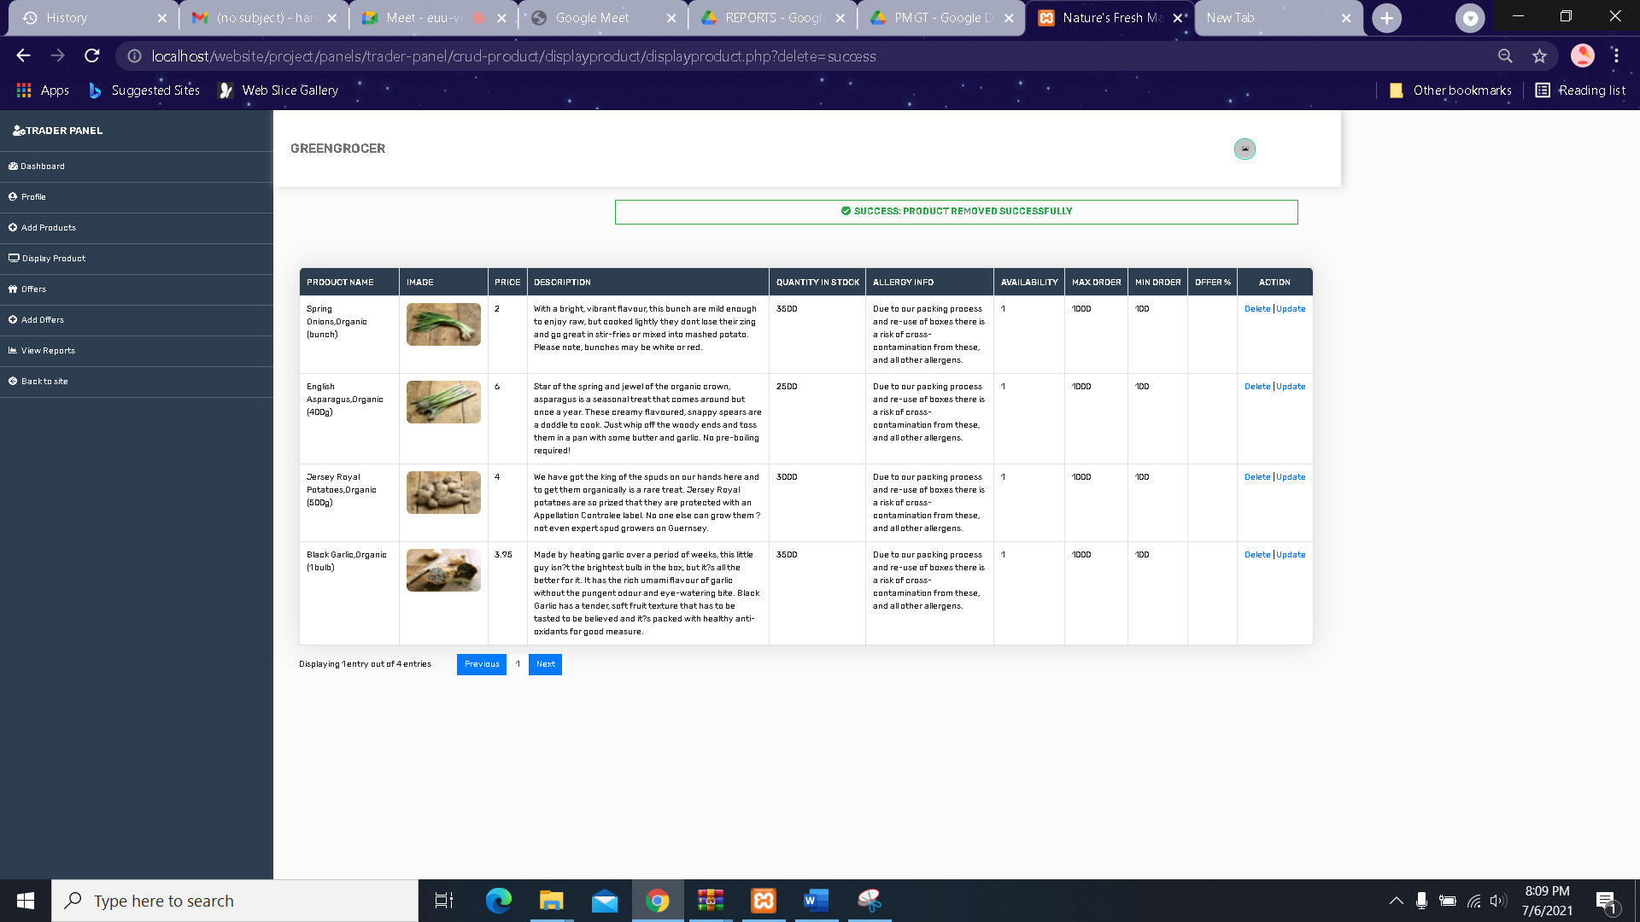

**UPDATE** any products from update button

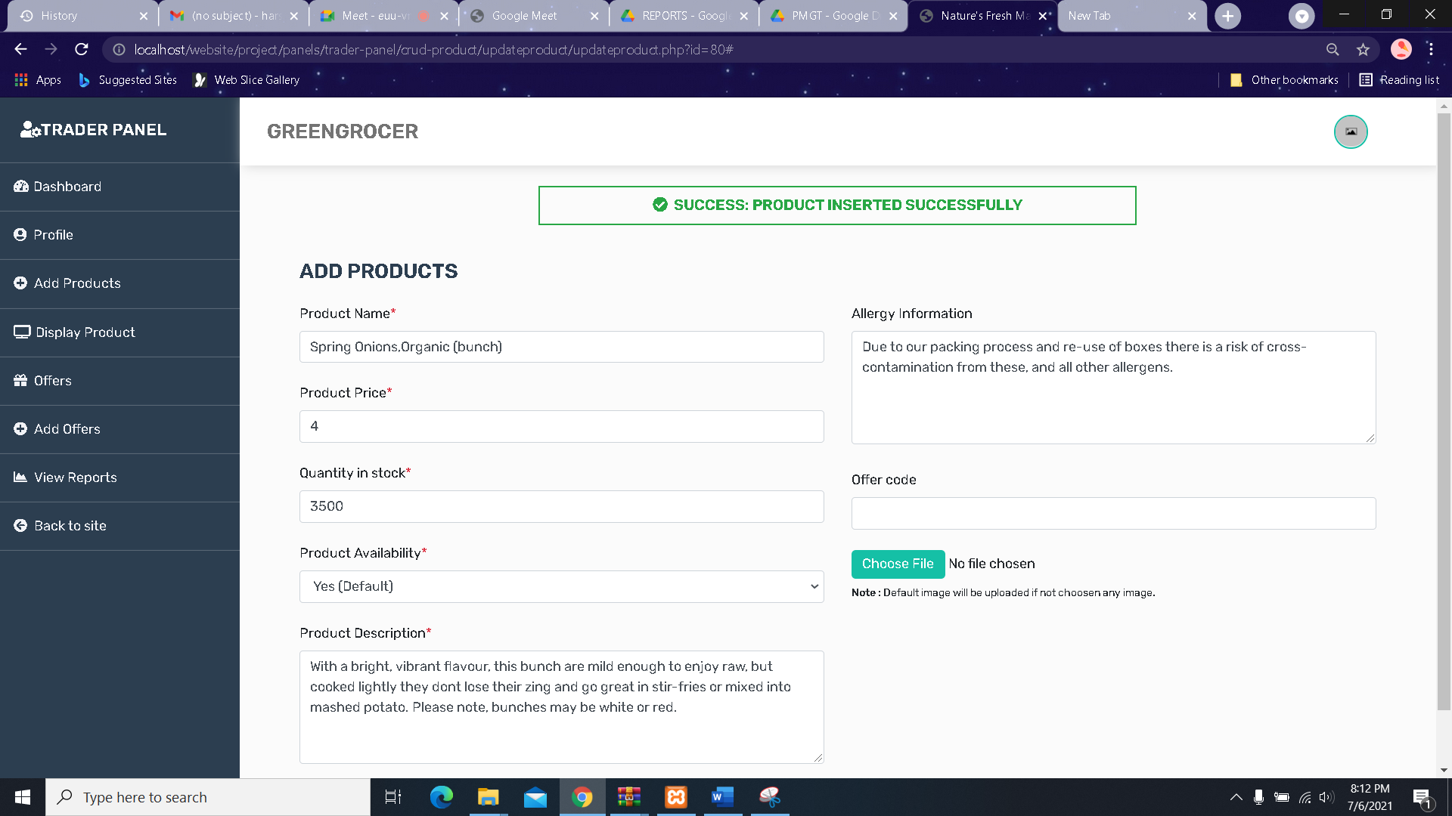

1. In the **Offers** section you can view all the offers your products may contain

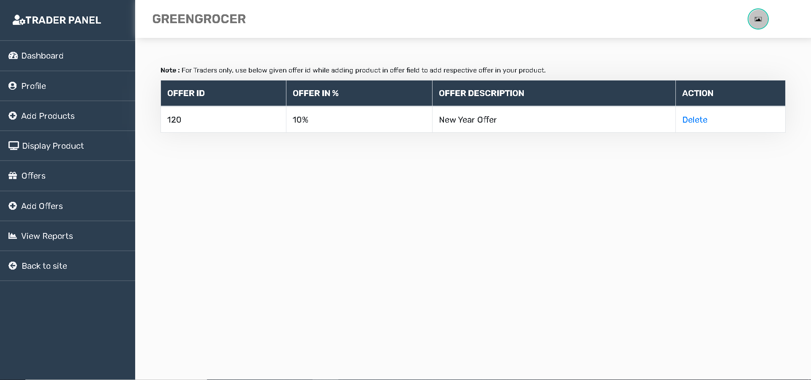

1. In the **Add Offers** section you can add new offers, set the offer percentage and provide a short description about the offers by filling out a simple form as shown below

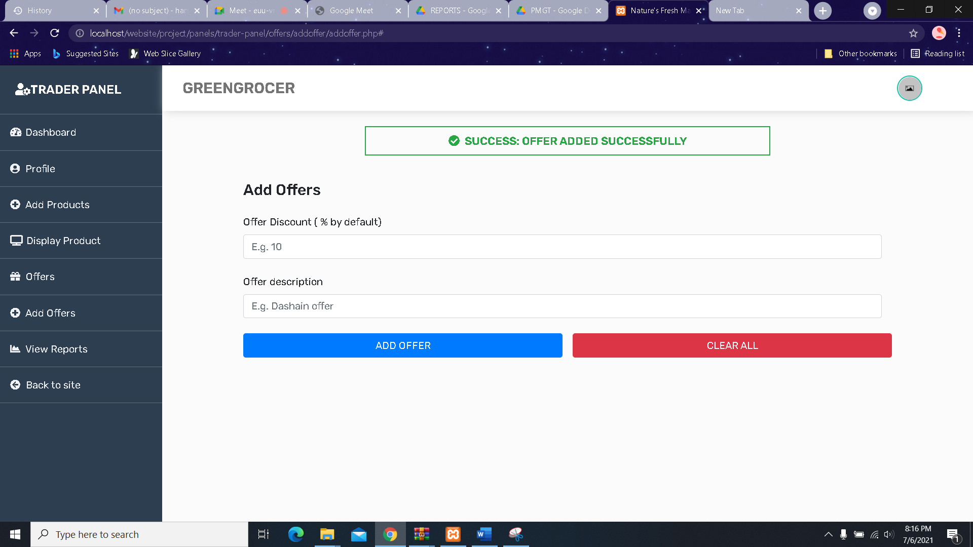

1. The next thing you’ll see is the **View Reports** button , when clicked will take you to the oracle application login page where after you login will can view different types of reports

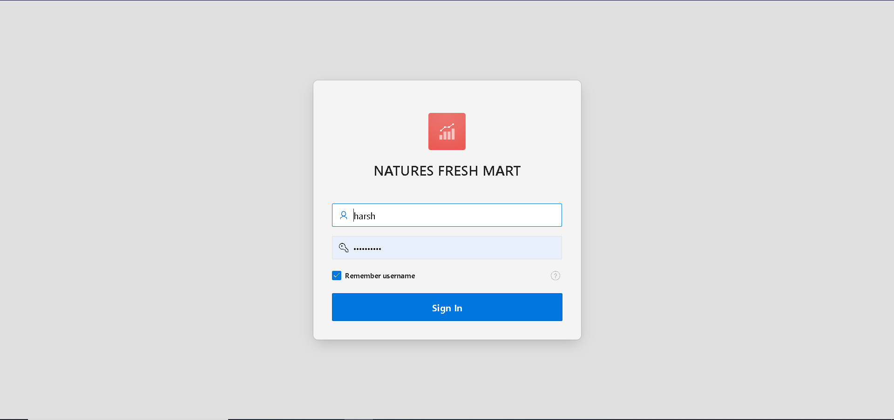

1. To **logout**, click the picture on the top right, click on Logout option.

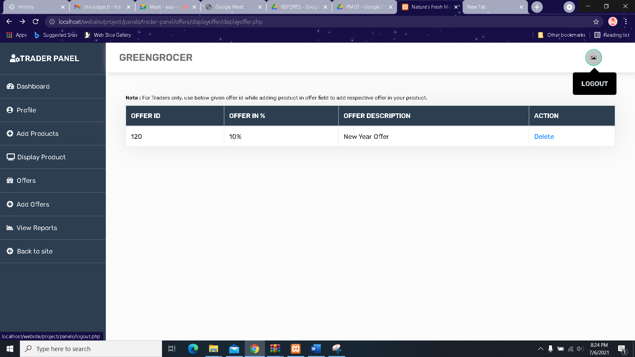

THANK YOU!!

**Directed To HOMEPAGE**

